**Huang Zhou’s subsystem Sales Instruction**

Business rules:

Any guest account can view the stock items

Only employees can add items to cart and checkout.

TestID & Password

**ID**: FillQuick

**Password**: Password1

Before running the project, make sure connection server changed to your local server name.

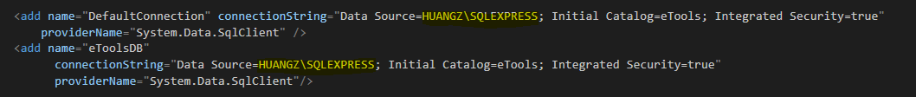

Database file is named: eTools.bak

1. Login into system as employee
2. Select items and add to cart
3. Edit/delete items
4. Check if coupon exits
5. Checkout the items

**To whom may concern**:

If you have any questions, please contact me at [zhouhuang.peter@gmail..com](mailto:zhouhuang.peter@gmail..com)

Thank You!